Slang Diction

🌀 What is Slang Diction
# Source: AI Source: Provided by: [Data Path: Persons Table -> ID Column: 1, Name_En Column: Motasem Essam] -> From: [Chatgpt (GPT-4-turbo)] on [7/30/2025]
Slang diction is highly informal, non-standard language that’s often playful, creative, and constantly changing. It’s usually used within specific social groups, such as teenagers, online communities, or subcultures.

✅ Key Features:
# Source: AI Source: Provided by: [Data Path: Persons Table -> ID Column: 1, Name_En Column: Motasem Essam] -> From: [Chatgpt (GPT-4-turbo)] on [7/30/2025]
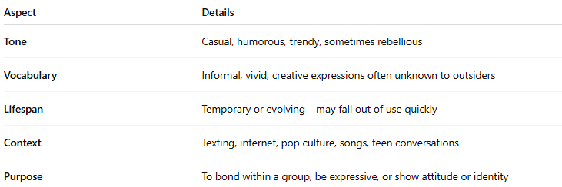
Aspect | Details
Tone | Casual, humorous, trendy, sometimes rebellious
Vocabulary | Informal, vivid, creative expressions often unknown to outsiders
Lifespan | Temporary or evolving – may fall out of use quickly
Context | Texting, internet, pop culture, songs, teen conversations
Purpose | To bond within a group, be expressive, or show attitude or identity

🧠 Examples of Slang Terms:
# Source: AI Source: Provided by: [Data Path: Persons Table -> ID Column: 1, Name_En Column: Motasem Essam] -> From: [Chatgpt (GPT-4-turbo)] on [7/30/2025]
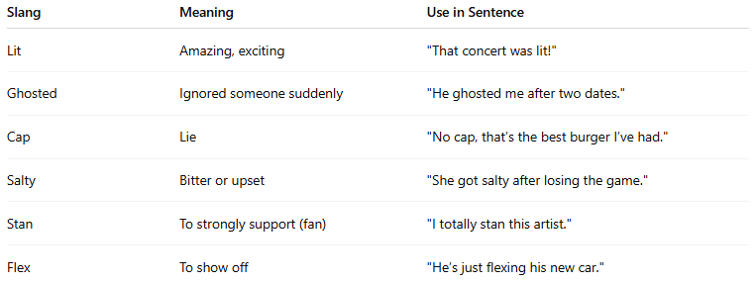
Slang | Meaning | Use in Sentence
Lit | Amazing, exciting | "That concert was lit!"
Ghosted | Ignored someone suddenly | "He ghosted me after two dates."
Cap | Lie | "No cap, that’s the best burger I’ve had."
Salty | Bitter or upset | "She got salty after losing the game."
Stan | To strongly support (fan) | "I totally stan this artist."
Flex | To show off | "He’s just flexing his new car."

🎯 Functions of Slang Diction:
# Source: AI Source: Provided by: [Data Path: Persons Table -> ID Column: 1, Name_En Column: Motasem Essam] -> From: [Chatgpt (GPT-4-turbo)] on [7/30/2025]
- Expresses attitude, emotion, or humor
- Builds social identity within a group
- Keeps outsiders out (acts like group code)
- Adds vividness to speech or writing

🆚 Compared to Other Types:
# Source: AI Source: Provided by: [Data Path: Persons Table -> ID Column: 1, Name_En Column: Motasem Essam] -> From: [Chatgpt (GPT-4-turbo)] on [7/30/2025]
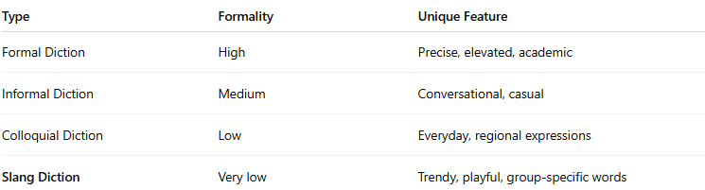
Type | Formality | Unique Feature
Formal Diction | High | Precise, elevated, academic
Informal Diction | Medium | Conversational, casual
Colloquial Diction | Low | Everyday, regional expressions
Slang Diction | Very low | Trendy, playful, group-specific words

⚠️ Note:
# Source: AI Source: Provided by: [Data Path: Persons Table -> ID Column: 1, Name_En Column: Motasem Essam] -> From: [Chatgpt (GPT-4-turbo)] on [7/30/2025]
Slang is not suitable for formal writing or professional settings. However, it's powerful for creating authentic characters, writing dialogue, or engaging with youthful audiences.

